**NIRMA UNIVERSITY**

**Institute of Technology**

**B.Tech. Computer Science and Engineering**

**2CSDE54 Information and Network Security**

**Perform encryption and decryption using the following block cipher techniques**

1. **Feistel Cipher**

**Feistel Cipher** model is a structure or a design used to develop many block ciphers such as DES. Feistel cipher may have invertible, non-invertible and self invertible components in its design. Same encryption as well as decryption algorithm is used. A separate key is used for each round. However same round keys are used for encryption as well as decryption.

**Feistel cipher algorithm**

1. Read list of all the Plain Text characters from the file (consider 2 character: block size)
2. Convert the Plain Text to Ascii and then 8-bit binary format.
3. Divide the binary Plain Text string into two halves: left half (L1)and right half (R1)
4. Generate a random binary keys (K1 and K2) of length equal to the half the length of the Plain Text for the two rounds.

**First Round of Encryption**

a. Generate function f1 using R1 and K1 as follows:

f1= xor(R1, K1) consider key k1: ‘A’

b. Now the new left half(L2) and right half(R2) after round 1 are as follows:

R2= xor(f1, L1)

L2=R1

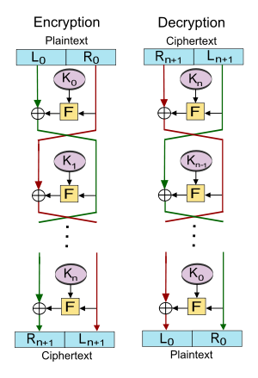**Second Round of Encryption**

a. Generate function f2 using R2 and K2 as follows:

f2= xor(R2, K2) consider key k1: ‘B’

b. Now the new left half(L3) and right half(R3) after round 2 are as follows:

R3= xor(f2, L2)

L3=R2

**Concatenation of R3 to L3 is the Cipher Text**

Same algorithm is used for decryption to retrieve the Plain Text from the Cipher Text.

**Note: Read the input from the file create a block of 16 bit i.e two characters at a time.**